**DIY Visualization**

This assignment is primarily about using the JET Cookbook and adapting that code to your own ideas. We are going to build a chart representing the number of hours you spend each week on different activitities. I will look something like this:

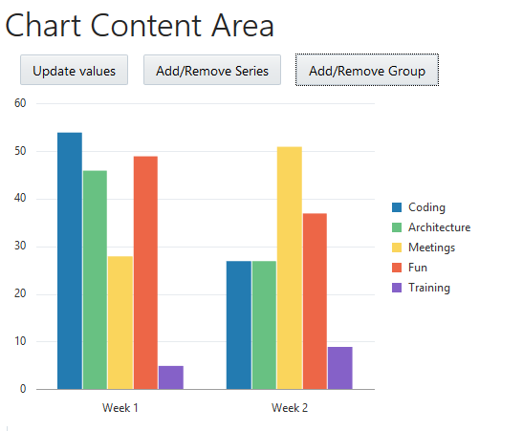

1. Go to the Cookbook, look at the Bar Chart component. Try to create the chart above in your own application.
2. Extract the hard-coded types of work and put them in a separate JSON file. Use the RequireJS text plugin to load this data in your application.

Extra

1. Do the same for all values for each group (advanced)
2. Add input field for the series and group that you want to add to the chart.
3. Split the buttons on the top so you can add multiple groups. Do the same for the Series button
4. Check the cookbook and the Jsdocs to make other improvements to your chart